1. 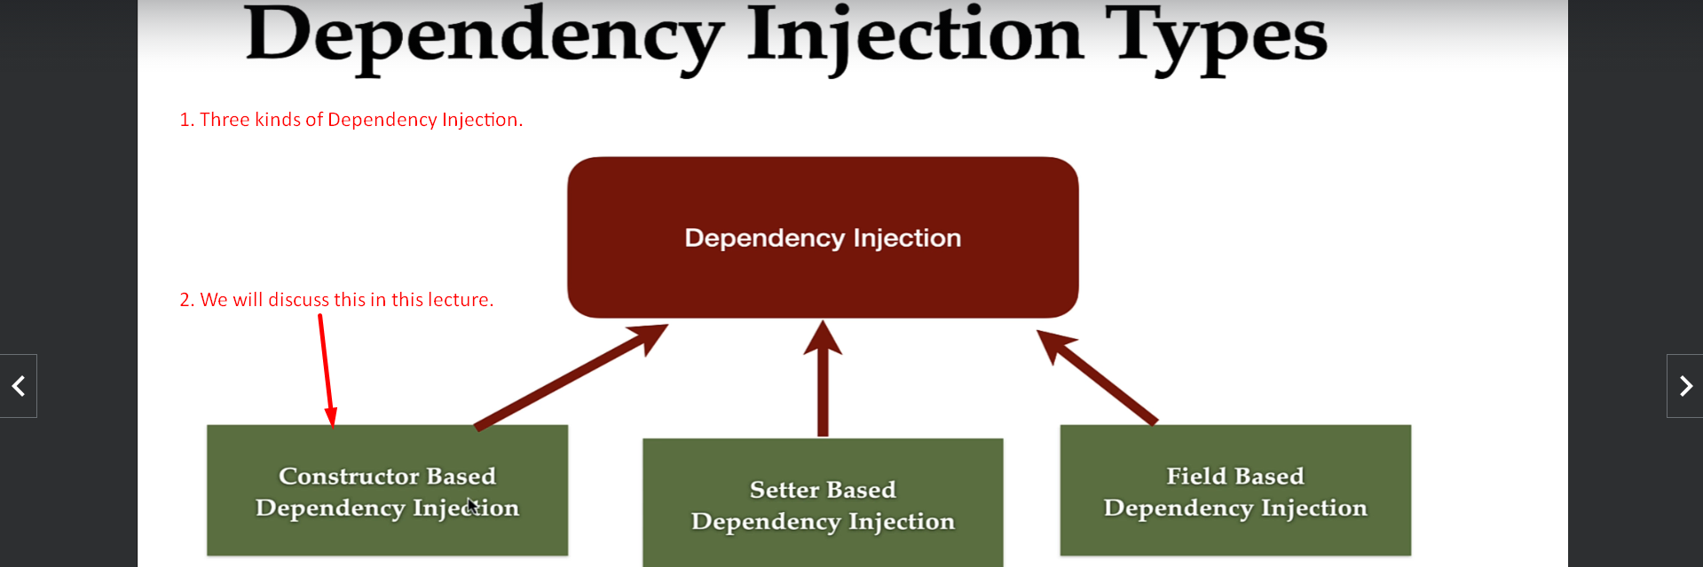
2. 
3. 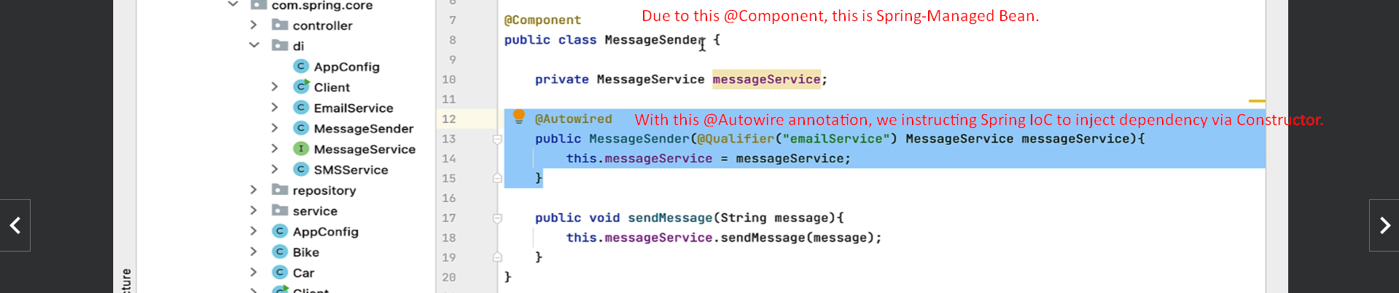
4. 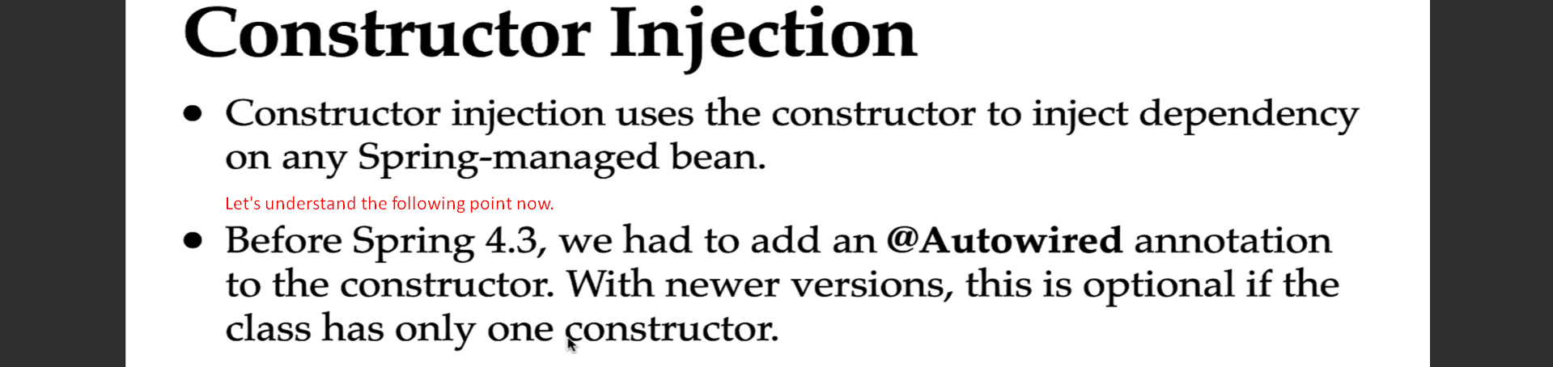
5. 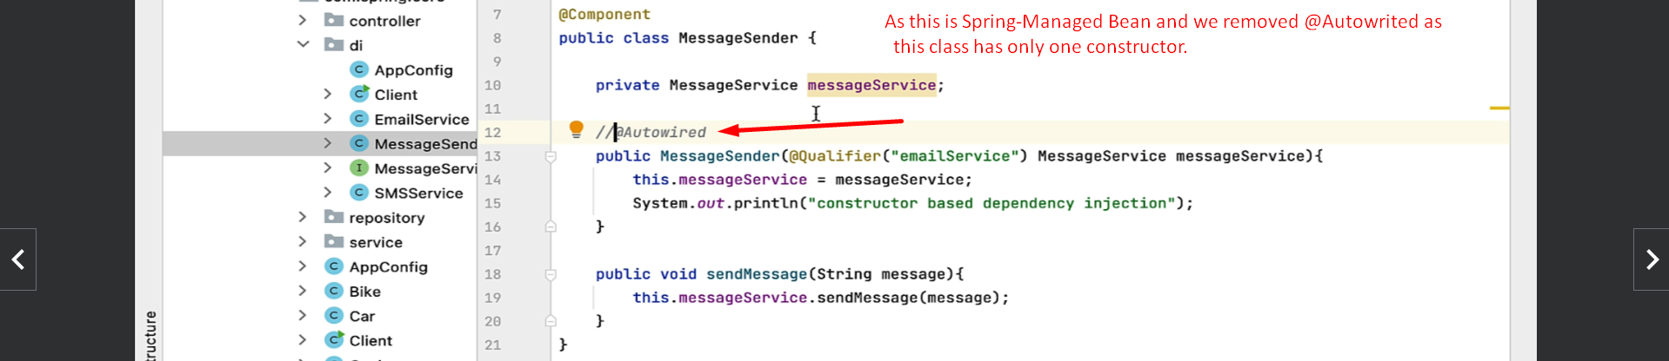
6. 
7. Let’s try to understand the point arrowed above.   
   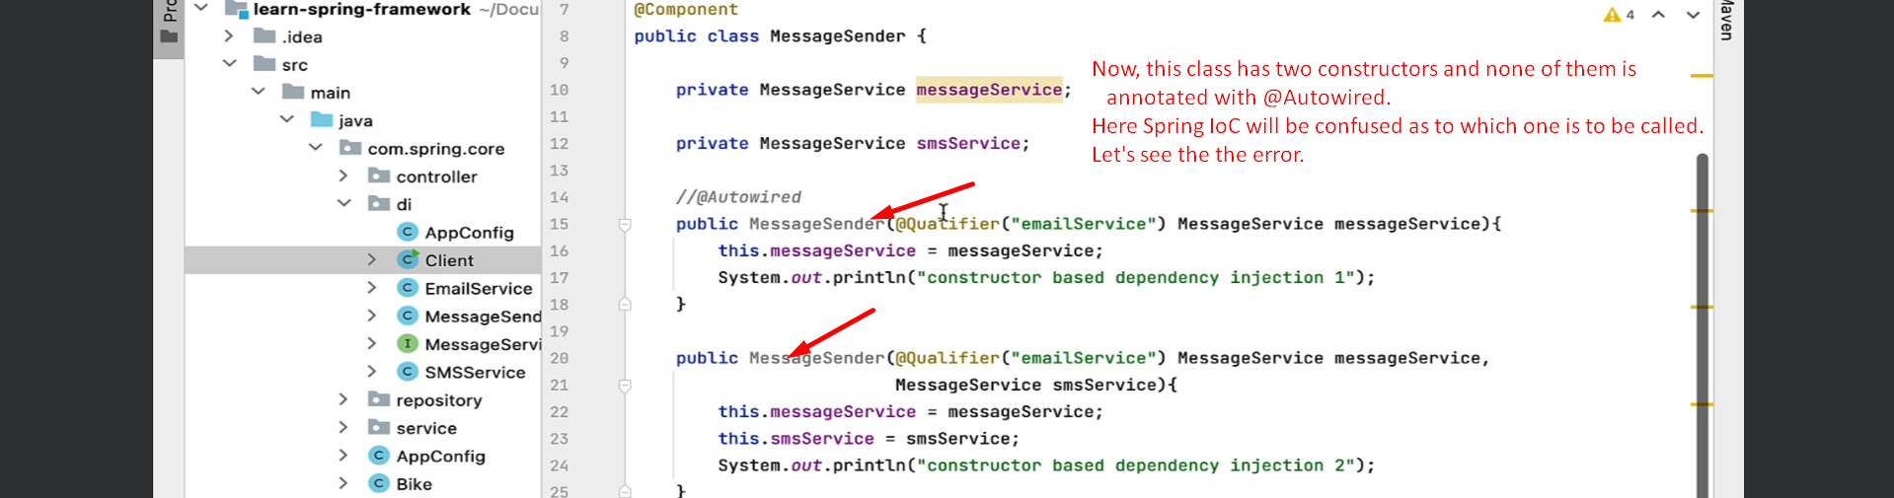  
     
   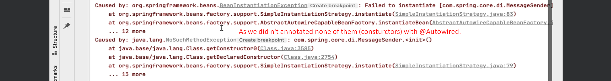
8. 